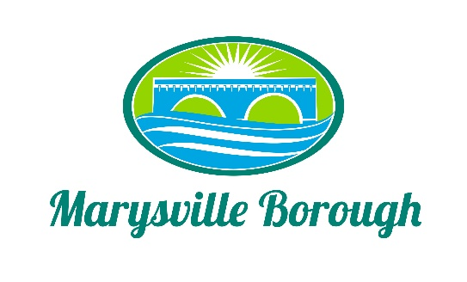

MS4 Meeting Minutes
March 7, 2022
5:00 PM

The MS4 Commission Meeting was called to order at 5:00 PM on Monday, March 7, 2022 at the Marysville Borough Office. Present were Commission Chair Leigh Ann Urban, Commission members Charles Wentzel, Dave Magee and Terry Kline. Borough Manager Zachary Border and Borough Engineer Greg Rogalski

New Business

- Approve Minutes from the Previous Meeting

A motion was made by Charles and seconded by Terry, to approve the minutes of the previous meeting. The motion passed unanimously
.
- Status of Contact with Locust Village

Zach and Greg updated the Committee, advising that a letter had been sent to the owners of Locust Village asking for permission to start to retrofit the stormwater basin on their property. If Locust Village has no objections, the next steps would be for an agreement to be done between the Borough and Locust Village.

3. Review of Engineer's Research - Flat Fee vs. Milage Increase

Greg presented different scenarios on how to implement the Stormwater Fee. Discussion was held on a flat fee, which could be based on impervious surface and a milage increase. The Commission asked Greg to come to the next meeting with some more information so that they could make decision on what route to go.

4. Discussion on Reinstituting the Former Authority

The Committee recommended to Council that the Solicitor start to look at reviving or creating
a new Stormwater/Sewer Authority.

5. Railroad Discussion

Leigh Ann gave some information on what it would look like if the Borough were to give a bill
to the Railroad and then try to negotiate an amount that they would pay. There will be more
discussion on this at the next meeting.

