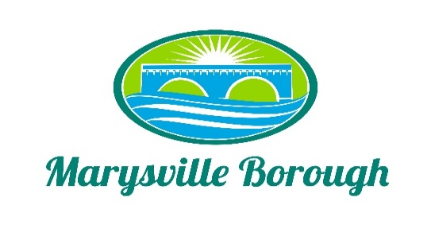

COUNCIL MEETING MINUTES
December 12, 2022

Executive Session
Borough Council entered to Executive Session at 6:03 p.m. Council exited Executive Session at 6:20 p.m. with no action taken.

6:00 p.m. Work Session
- Sherriff Sales
Zack Border, Borough Manager said we have looked in to specific properties. Councilmember Magee stated we are first, in fact Municipal Liens come first. Zach Border said he has the figures for the house discussed with Councilmember Webster.

- Golf Carts on Borough Roads
Councilmember Zulli stated at the Streets Meeting on December 5th a resident utilizing a golf cart on the streets near his home. Questioning to include within our Ordinance to specifically addressing golf carts on our city streets and how we go about including language that is broad enough to encompass a variety of what can be driven down our streets. Council President Barthel mentioned Riding Mowers, as well as Councilmember Edkin. Some discussion about motorized wheelchairs, which is separate for this discussion. Councilmember Webster said there may be some requirements must be equipped to inspection standards. Since our Police Officers are not at the meeting he would defer to Kelly (attendee Kelly Wetzel). Mr. Wetzel felt with these vehicles Mr. Wetzel was in attendance and stated and mentioned “up north” roads will be designates roads specifically for UTV’s to travel from one point to another. With Municipalities up north DCNR requires side by side, but dirt bikes, etc. are not allowed. Mr. Wetzel said without looking in to it is the backdrop Title 75 violation because it is not suited for travel on a roadway is the issue. Councilmember Wentzel asked by default they are already not allowed. Zach Border mentioned Aaron Richards said there is a certain amount of distance they can go. Aaron came to him President Barthel said there is a provision this needs to be investigated. Councilmember Magee and others mentioned reaching out to other municipalities and borrow their provisions. Attendee Rich Stees wanted us to include electric vehicles.

3. 2023 Meeting Schedule
Borough Manager, Zach Border said we do not typically have any meetings in January, except for Finance (January 4th) and Council (January 9th) Meetings. In the past, Council President Barthel stated there are not any meetings the first week of January because we need to see who is on what Committee.

7:00 p.m. Borough Council Meeting

Council President Barthel called the meeting to order at 7:00 p.m.
Marysville Cub Scout Pack 56 was in attendance.

- Pledge of Allegiance
President Barthel asked the Cub Scouts to lead those assembled in the Pledge of Allegiance.

- Moment of Silence
A moment of silence was held.

- Roll Call
Council President Barthel took roll call with the following noted as present: President Barthel, Vice President Wentzel, Councilmembers Edkin, Magee, Webster, Urban, Zulli and Mayor McCreary. Also in attendance were Borough Manager Border and Office Secretary Rhome. Secretary Hammaker, Engineer Rogalski, Treasurer Chorba, and Solicitor Altland were noted as absent.

- Consent Items
- Approval of the 11/14/2022 and 11/22/2022 Council Meetings Minutes.
- Approval of the Financial Statement
- Approval to Pay Bills
Councilmember Magee made a motion to approve all the Consent Items with Councilmember Edkin seconding. One comment by Councilmember Magee and he had it answered, therefore he is okay with the motion. Passed unanimously.

Public Comment (Please Keep to a Three (3) Minute Time Limit)
a. Attendee Rich Stees mentioned an article about COMCAST increasing their rates about 4%. He heard a lot of comments from Residents about interruption of service, TV going off or picture freezes. When you give them a call it magically works now. It seems it is not just an individual problem, but a systematic issue. Since the town has a franchise with COMCAST, it needs to go on record that we as Residents are not pleased with the service we are getting. Council President agreed and asked where we were in the Contract process. Zach said the Contract is done and was done last year.
Council Vice President Wentzel asked if there was an arrangement in the contact to get feedback reports of outages. He also said he has problems himself. Zach said it was Cohens was the group that negotiated the franchisee for COMCAST. He can reach out to them, even a letter from the Bourgh Manager. Councilmember Webster said he has been hearing a lot about the throwing it down of the lines. Conversation pursued regarding fiberoptics, metal wires, the internet service, etc.

b. The second thing Mr. Stees wanted to do was recognize Dave Magee for his dedication to the community throughout his years on Council. He certainly helped him with the Pool, the Veterans Wall, Railroaders Memorial, and a lot other things for the community. He is one of the few people we have had on Council he feels is a real visionary. Somebody that is forward thinking and another item is the Bridge Project at the Lions Club. As an individual and he feels he can speak for the rest of the Community to thank Councilmember Magee for what all he has done. He thanked Mr. Stees for his comments. President Barthel said for those that may not know this is Dave’s last Council Meeting.

c. William Gumbinger from Maple Avenue stated he has two things as well. One is, has it ever been discussed putting a speed bump in about Union Street comes down by the Lodge into Verbeke Street at the corner. Council President said we cannot do traffic control or regulate speed with a speed bump. It has been tried before. Councilmember Edkin knows where Mr. Gumbinger is referring to.
d. The second if Breakfast with Santa. A couple of miscommunications with the times the even was to happen. The Marysville Moose Lodge covered from 8:30 a.m. to 11:15 a.m. He felt the Newsletter could have been out earlier. He did not get the turn out he thought they would get, but those that came enjoyed themselves and had a great time. Bills are being submitted for reimbursement.
With the Marysville Borough Newsletter going Digital next year that will not be an issue.

6. Engineer’s Report
a. MS4
Councilmember Urban stated there was a meeting last Monday and a review of the study that was done, but not done. Engineering Firm went in and did an assessment of the coverage and there are some numbers and line that are off and so Greg and Company are going to go back and review. In the meantime, they are going to give us a chart that assesses a 3-4-5 year term of what it would look like if we charged a fee based on those different year terms. So, that will be our next move is deciding as a MS4 Commission what to recommend to Council to move forward with that process.

7. Old Business
a. South Main Street Bridge Project
Nothing new from the last meeting when Todd was here.

b. Cameras for Public Works Complex
Tabled
i. Alwine
ii. DGL

8. New Business
a. Motion to approve Resolution Number 354 setting the borough tax rate for 2023
Council Vice President Wentzel made the motion to approve and Councilmember Webster
Seconded. All millage on real estate both to Marysville in general as well as the Fire Company, street light services, and the millage rate per dollar for Occupational Tax Rates and all are the same as last year. Therefore, no rate increase. Motion was unanimously passed.

b. Motion to approve the 2023 Budget
Motion was made by Councilmember Webster and seconded by Councilmember Wentzel. This is the Budget that came out of Finance and advertised in November. Council President Barthel said it has been out for review quite a while for review. Councilmember Magee stated he had two issues. One with tapping fees and one with zoning permits. Discussion included the fees and if needed dropping the capital outlay in that same section. Councilmember Edkin expressed his concern for future budgets and new construction ends, referencing White Tail Development. Phasing out over a period is more acceptable. Discussion included it is a lower rate than the previous year. Zach explained originally there was $90,000.00 budgeted and it was lowered to $60,000.00 Anything 10% or less does not have to be allocated relating to expenditures. Vice President Wentzel and Councilmember Magee agreed to plan long term to lower those numbers. President Barthel stated for the record these concerns are noted by Vice President Wentzel and Councilmember Magee for next year’s budget. The motion was passed except for Councilmember Magee opposing.

- 2023 Meeting Schedule
All Council Members has reviewed the schedule. Councilmember Edkin made a motion to advertise and was seconded by Councilmember Webster. The motion was passed unanimously.

- Motion to approve Ordinance Number 644 regarding Act 57
This Ordinance allows the Tax Collector and the County to forgive penalties. If someone moved in within a year and they did not get their tax bill, it allows the Tax Collector or the County to waive the penalties. Vice President Wentzel made a motion for approving the Ordinance and seconded by President Barthel. The motion was passed unanimously.

- Motion to approve the agreement with Pennoni for Lions Club Park PRP Project – Final Design and Permit
Motion was made by Councilmember Urban and seconded by Councilmember Magee. Councilmember Urban stated plans are included in Council’s packet that Pennoni presented for $31,000.00. Work to begin early 2023. Attendee Rich Stees asked if there is a Public Meeting portion to that contract to present plans to the public. Zach Border expressed there will be a public meeting for the fees. He said the PRP Project has been out there since 2017. President Barthel said at the next meeting for the fees that will be part of meeting. Councilmember Urban voiced at the Stormwater Authority Meetings it was discussed there would be two outreached meetings between now and the middle of next year, to not only present some of these ideas for public input, but talk more about the fee and why it is needed. She did not think anyone meeting will be fee focused. The motion was passed unanimously.

- Motion to approve the quote from 911 Rapid Response to decal the 2018 Explorer in the
amount of $1650.00
Councilmember Webster made to motion to approve and seconded by Councilmember Urban.
Discussion included the Police Department wants more visibility for when that car is utilized. Money is allotted in the budget for this work. Also, there was questioning of acquiring more than one bid. This company was used for our other police vehicle. The motion was passed unanimously.

- Motion to Advertise the revised Zoning Ordinance and set a date for a Public Hearing
Dan Altland, Solicitor stated there was enough time he could do it in January 2023. Zach Border did send it out in an email. Councilmember Urban mentioned setting a date in February giving the new member time to review. Vice-President Wentzel not in agreement. He feels it is a large document (130 pages). Councilmember Magee felt March would be better. President Barthel asked Council start at February 13, 2023 at 5:30 p.m. instead of 6:00 p.m. Vice President Wentzel made the motion and seconded by Councilmember Magee. The motion was passed unanimously. Clarification question: not linked to the Website because it is in DRAFT form, not a Public Document.

- Golf Carts on Borough Roads
Need a motion for the Solicitor look at updating out Ordinances for different vehicles such as golf carts, ATV’s, riding mowers, etc. that are being driven on our roadways. Councilmember Zulli made a motion to have Dan investigate other towns, boroughs, that have unregistered on motor roadways such as golf carts, ATV’s, riding mowers, etc. and seconded by Councilmember Magee.
Zach Border will reach out to the Borough’s Association and the Tri-County and forward to the Solicitor. Councilmembers Edkin and Webster voiced that due the shortage in the office time Zach should be given time to gather information for the development of an Ordinance. Streets could review. Motion was not passed.

9. Commission Reports
a. Planning Commission Report
Planning Commissioner Scott Artley said only two individuals attended.

b. Code Enforcement Officer’s Report
Zach Border said his report was submitted. Councilmember Magee inquired if District Justice reports were in the packet. Zach explained there were three and they are in the back of the packet.

c. Police Department Report
No Police in attendance. Mayor Michael McCreary reported he has been receiving a lot of comments from the Community that the Police have been a lot more visible and that is a very positive. Councilmember Magee agreed he has heard the same comments.

- Fire Company Report
No one in attendance from the Fire Company

10. Committee Reports
- Personnel
Nothing from Personnel

- Finance
Vice President Wentzel stated we went over in Budget

- Sewer/Sanitation/Streets
Councilmember Zulli reiterated Golf Carts on the Borough Streets, etc. Also, a discussion with Greg regarding Overcrest and reaching out to the homeowner.

- Parks, Recreation, and Pool
Vice President Wentzel mentioned we already discussed the Bridge Project in the Lions Club area to remove bridge and paint as well as redo the trailways and the work being completed inhouse which is under a very tight deadline. Second, addressing the Grants we have towards redoing the playground in the Lions Club Area which will involve the redoing the surface area, etc.
Councilmember Magee said in the Spring it is planned to have the Dedication of the Railroaders’ Memorial. He mentioned the Westside Singers would be coming to the dedication when a date was decided and they could see if they were available. The Rockville Bridge was opened on March 30, 1902 and April 1st is a Saturday and it would be perfect. Councilmember Magee also mentioned Steve Nailor should be invited because if it would not have been for him, we would have never gotten a Grant for $50,000.00 or $60,000.00 to tear down the building and get things in place.
Vice President Wentzel mentioned and conversation about interest in a Pickleball Court.

- Managers’ Report
Zach Border reported Leaf Collection ended last Friday for the Season. We did have a truck hit the Red Light on Routes 11&15 and the person that did the damage was caught. We are pursuing them to costs to repair the pole, etc. Liquid Fuels Auditor is due in the office on Wednesday.

11. Correspondence
None

12. Public Comment (Please Keep to a Three (3) Minute Time Limit)
None

13. Media Questions
One of the Cub Scouts asked what is President Barthel’s favorite part of the job? He responded, “Helping the Community.”

Next Scheduled Meeting will be on: January 9, 2023

Councilmember Webster said this is the last Council Meeting for December and he would like to thank Dave for his service on Council as well as Vice President Wentzel.

Councilmember Magee said he truly enjoyed working with everyone. He then made the motion to adjoin the meeting and it was seconded by Councilmember Urban.

BOROUGH OF MARYSVILLE
Borough Council Committee Meeting
December 12, 2022
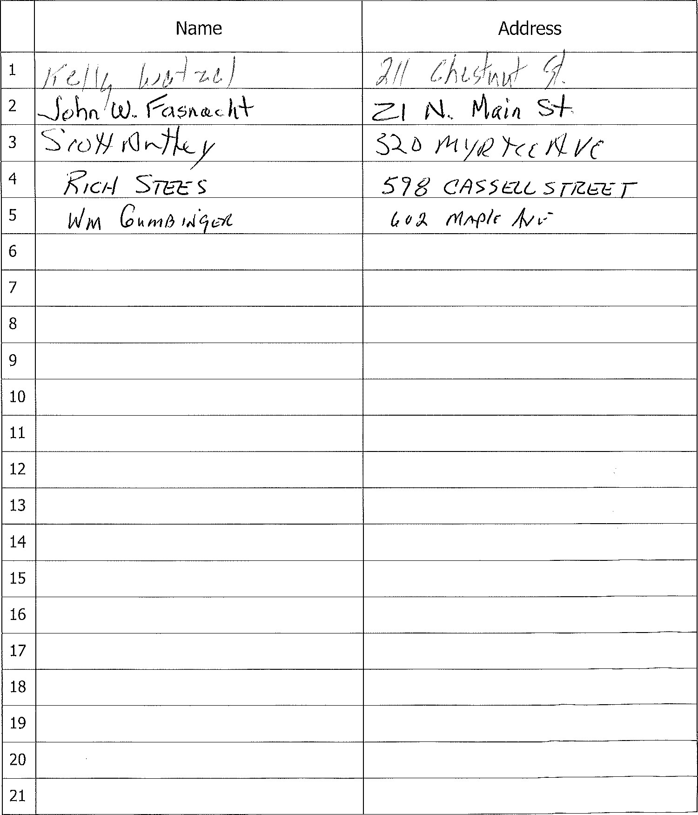
Sign-in
Sheet

