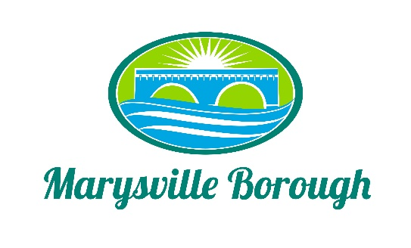

SPECIAL COUNCIL MEETING AGENDA
July 20, 2022

5:00 PM Borough Council Meeting

- Pledge of Allegiance
Council President Barthel called the meeting to order at 5:00 PM.
2. Roll Call

Council President Barthel took roll call with the following noted as present: President Barthel, Vice President Wentzel, Councilmen, Magee, Webster, and Councilwomen Zulli. Also in attendance was Manager Border. and Secretary Hammaker and Treasurer Chorba. Councilman Edkin Council Women Urban Secretary Hammaker Treasurer Chorba Solicitor Altland and Engineer Rogalski were noted as absent.

4. Public Comment
There was no Public Comment

5. New Business
a. Administrative Assistant
A motion by Councilwomen Zulli to hire Brittany Hammaker as a part time administrative assistant a second was made Vice-President Wentzel. All voted in favor of the motion

6. Public Comment (Please Keep to a Three (3) Minute Time Limit)
No Public Comment
7. Media Questions
No Media
A motion to adjourn was made by councilman Magee and seconded by councilman webster. All voted in favor of the motion, The meeting was adjourned at 5:13 PM

