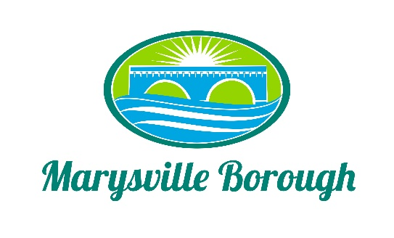

Marysville Borough
Finance Committee Minutes
September 8, 2021
5:30 PM
The Finance Committee Meeting was called to order at 5:30 pm on Wednesday, August 5, 2021 at the Marysville Borough Office. Present were council members Dave Magee and Charles Wentzel and Brian Webster Also present were, Borough Manager, Zachary Border and Administrative Assistant, Kim Charles
Charles did leave around 6:30 and was replaced my Leigh Ann Urban to finish the meeting
New Business
- Executive Session Legal

The committee went into executive session at 530 and come out around 545 to discuss legal issues.

- Wireless Ordinance

CAPCOG presented a proposal from the Cohen Law Firm to assist the borough in rewriting their wireless ordinance to come in compliance with ACT 50 this would allow the borough to charge a fee to telecom companies for small wireless antennae’s and allow the borough some control over design.

- Bonds

Bonds were discussed as a way to finance MS4 it was referred back to the MS4 for further evaluation

- Cap Tax

The Committee would like Zach to request all the brough documents that CAP Tax has for the committee to review.

- DEP Grant

The Committee decided it would be a good idea to pursue this since the award would not be given to next year the borough could put the match I next years budget.

- Garbage Contract

Old Business
- 2021 Budget
- Parks and Rec Tax
- Updated insurance numbers
- Financial Plan for MS4
- 2022 Budget

Public Comment

