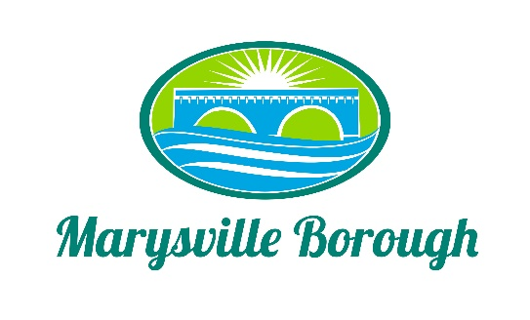

Marysville Borough
Finance Committee Minutes
February 9, 2022
5:30 PM
The Finance Committee meeting was called to order at 5:30 PM on Wednesday, February 9, 2022 at the Marysville Borough Office. Present were Council Members Leigh Ann Urban, Brian Webster and Charles Wentzel. Also present was Borough Manager, Zachary Border.
New Business:
Elect a Chair
With only two members of the Committee present, Charles was made temporary Chair in order to run the meeting. The official Chair will be decided at the March meeting.
Roof Repair
In 2021, the Committee was presented at quote for the roof repair at the Waste Water Treatment Plant but wanted to wait until the new budget year to act on it. Zach presented the quote to the Committee again and the Committee recommended moving forward with the project.
Sell the Borough Car
Council wants to look into options for selling the Borough car but would first need to buy a new one so Zach can use it for Code Enforcement. The Committee directed Zach to look around and price new cars.

Fire Cabinet
Zach presented the Committee with a quote for a fire proof cabinet that came in at a lower price than a previous quote from last year. The Committee recommended this purchase to Council.
Pool Manager/Pool Employee Rates
The Committee decided that the rates should stay the same since the pool staff was given a $1.25 per hour raise the previous year and that when Zach talked to the staff about a raise, they all seemed okay with that rate.
Term Investment PLGIT
It was decided that with all the other projects going on, right now would not be the time to invest.
Old Business:
2022 Budget
A few questions were asked about the budget and answered by Zach.
Sewer Billing
Tabled
Fee Schedule
Tabled
Public Comment:
None

