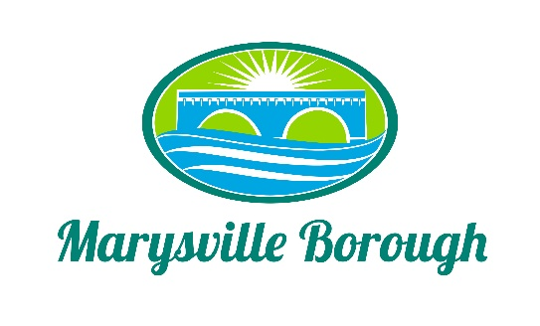

Marysville Borough
Finance Committee Minutes
October 6, 2021
5:30 PM
The Finance Committee Meeting was called to order at 5:30 pm on Wednesday, October 6, 2021 at the Marysville Borough Office. Present were council members Dave Magee and Charles Wentzel and Brian Webster Also present were, Borough Manager, Zachary Border
New Business
- Security Cameras

The Committee decided that at this time they should not move forward with cameras but would look at it at a later date.

- New Pump for Pump Station 1

The pump at pump station one needed to be replaced it was aging and had failed. The committee agreed to send this to council for approval.

- 90-Gal Flammable Cabinet Self Closing Safety Cabinet Door

The Committee decided to push this to next years budget.
Old Business
- 2021 Budget
A few questions were asked about the budget and were answered by the borough manager.
- Parks and Rec Tax

Dave wanted to discuss put this on the agenda as a discussion for being able to pay for future parks and Rec activities.

- 2022 Budget

The committee continued to craft the 2022 budget for council approval.

- Cap Tax
This was tabled.

Public Comment

