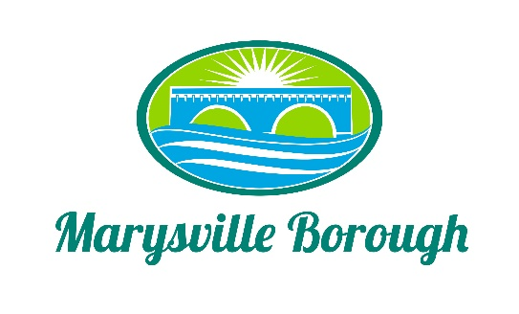

Marysville Borough
Finance Committee Minutes
November 3
5:30 PM
The Finance Committee Meeting was called to order at 5:30 pm on Wednesday, November 3, 2021 at the Marysville Borough Office. Present were council members Dave Magee and Charles Wentzel and Brian Webster Also present were, Borough Manager, Zachary Border

New Business
- Roof Proposal

Zach presented a proposal from Dreamworx roofing to repair the roof at the treatment plant. With how late in the year it was the Dreamworx would not be able to do the job until 2022. The committee decided to hold off on moving it forward with council until the 2022 budget year.

- Cleaning the Wet Well

Zach presented a proposal to clean all three wet wells at the pumpstations that have not been cleaned in about 3 years or so and this is routine maintenance that should be done to keep the system working properly. This was recommended to council for approval

- Payroll

Zach presented a proposal from Paychexs to take over time and attendance and payroll for the borough. The committee thought this would save time in the office and recommended this to council for approval

- Sewer Billing

This was tabled

- Park Drive

The Committee discussed if the borough should pay for this problem in lateral on Park Drive. The committee decided to send this to council for a discussion with all 7 members
Old Business
- 2021 Budget
Questions were asked and answered by the borough manager
- 2022 Budget

The Committee recommended that council advertise the 2022 budget.

- Cap Tax

Tabled

