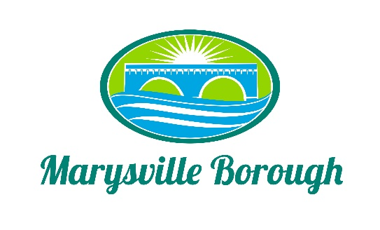

Marysville Borough
Finance Committee Minutes
December 8
5:30 PM
The Finance Committee Meeting was called to order at 5:30 pm on Wednesday, December 8, 2021 at the Marysville Borough Office. Present were council members Dave Magee and Charles Wentzel and Brian Webster Also present were, Borough Manager, Zachary Border
New Business
- Financial Statement Review

George Lane was in from Boyer and Ritter was in to review the 2020 Financial Statement.

- Budget Reallocation

Zach presented the budget allocations from the General Fund the committee agreed to recommend it to council.

- Fee Schedule changes

Zach wanted the committee to review the fee schedule and see if there were any changes the only thing that changed was the trash fee.

- Skid Loader

The committee decided to not fund the skid loader this year and would relook at it next budget year.

- Surplus Funds

There was some discussion on what to do with the surplus fund but no decision was made

- Audit

The committee discussed doing a forensic audit but decided to not move forward at this time.

Old Business
- 2021 Budget
Discussion on this item was handled earlier in the agenda under budget reallocation
- 2022 Budget

The Committee recommended final approval of the budget for council.

- Cap Tax

Tabled

- Sewer Billing

Tabled
Public Comment

