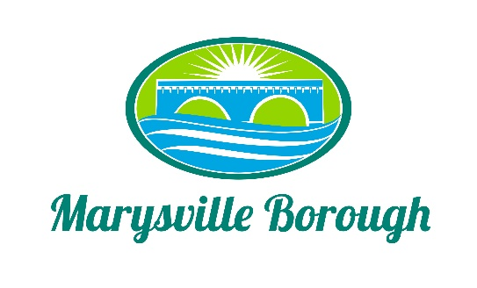

Stormwater Authority Agenda
April 3, 2023
5:00 PM

The MS4 Commission Meeting was called to order at 5:00 PM on Monday, April 3, 2023 at the Marysville Borough Office. Present were Commission members Charles Wentzel, Dave Magee and Terry Kline; Administrative Assistant, Haley Briner and Borough Engineer, Greg Rogalski.

New Business

- MS4 Waiver
We were on a waiver in previous years, but the Borough needed to be under 1,000, which they aren’t, so we are unqualified.

- Rules, Regulations & Fees
Greg is willing to present proposed stormwater fees in his presentation on April 17th, 2023 at the public hearing meeting. Greg noted that he believes the Solicitor should set up fees.

- Projects & Financing
Discussed American Recovery Fund monies allocated to MS4 for upcoming projects.

- New Chairperson
Tabled until next meeting.

- Prepare for Community Meeting: April 17, 2023
Discussed set-up/tear-down procedures & to contact Mary Ellen Brown with the Lion’s Club regarding audio & visual.

- Non-Residential Fees
The proposed fee structure per ERU- 3,560 SF of non-pervious surface per lot.

- Solicitor
4-0 vote to send out an RFP for a Solicitor for the Stormwater Authority

- Grants
Dave Magee volunteered to visit the county grant writer to assist in finding federal funding for the upcoming stormwater management projects.

- Secretary/Recording Administrator
Charles Wetzel volunteered, seconded by Terry Kline.

Old Business
- Fee Study update / Credit Impact
Dave proposed to portray fees at the calculated $38.00 per ERU’s. Greg agreed.

- Locust Village Update
The retrofit of the storm basin was completed at the end of March 2023. Waiting on the final punch list from the contractor. Expected to see a pay application in April-May 2023.

- Lions Club Pond/ Design Fees
Discussed that this will be the next project to be worked on for MS4 best management practices.

Other Business

Public Comment

Haley Briner: How does the Stormwater Authority intend to send bills to the residents?
Dave asked what her opinion was since she is currently assisting with the sewer & trash billings, to add it onto the sewer and trash billings as a separate line item. Greg mentioned that other Municipalities that do billing the same way apply any partial payments to the Stormwater amount first.

Chief Aaron Richards: What’s going on with the Norfolk Southern accident on South Main Street because there are still derailed railroad cars and trees on the power lines?
Greg informed us that Embark owns the lines and they reported that they ‘will get to it’.

The meeting adjourned at 6:00 p.m.

