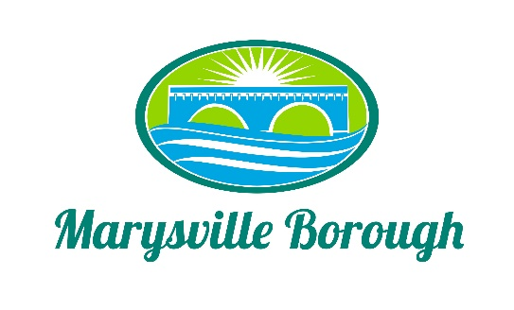

MS4 Meeting Agenda
September 7, 2021
5:00 PM

Members: The MS4 Committee Meeting was called to order at 5:00 pm on Tuesday, September 7, 2021 at the Marysville Borough Office. Present were Leigh Ann Urban, Charles Wentzel and Dave Magee and Borough Manager Zachary Border

New Business

- Election of a chairperson.

The committee decided to nominate Leigh Ann as the committee Chair.

- Addition of members to the committee from the public

Zach reported that after speaking with Dan his opinion was that in order for members of the public to serve the committee would need to be called a commission. The committee discussed how the committee would work such as how many members, how long terms would last and how long the commission would exist. It was decided to be a 5-person commission that was appointed by council and with no ending date would be the best way to start the process. This was then recommended to go to council to vote on the commission.

- Memo of Understanding between Marysville and Perry County Conservation District

This was standard agreement between the two entities. This will help to also satisfy an ms4 requirement.

- Financing for MS4

A number of options were discussed at the meeting such as a fee assessment a tax increase and a bond. The committee asked Zach to run numbers for each of the options for them to make a better decision.

- Stormwater Authority

This was tabled until the new commission was formed.

