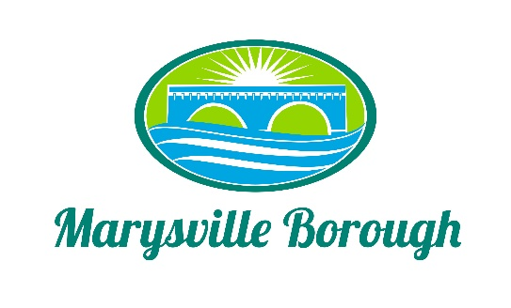

MS4 Meeting Minutes
November 1, 2021
5:00 PM

Members: The MS4 Committee Meeting was called to order at 5:00 pm on Monday November 1, 2021 at the Marysville Borough Office. Present were Leigh Ann Urban, and Dave Magee and Borough Manager Zachary Border

New Business

- Public Outreach – website, social media - for community volunteers

Leigh Ann created a document to be shared to the website and facebook to advertise that the borough is looking for volunteers to be on the commission

- Role of Council - how many council members?
Dave suggested the commission have 7 members Leigh and wanted to wait to see ihow the response would be for volunteers

- Discuss potential timeline / Current status of projects in PRP

Greg sent a timeline of events that should take place over the next 2 years in order to come into compliance with the permit.

Old Business
- Financing for MS4
- Flat Fee
- Millage Increase
Zach presented numbers for both a flat fee and tax increase. The commission decided to wait and discuss the numbers until the full commission meets

- Storm Water Authority

No Discussion

