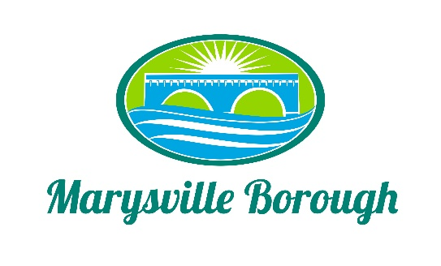

MS4 Meeting Minutes
February 7, 2022
5:00 PM

The MS4 Commission meeting was called to order at 5:00 PM on Monday, February 7, 2022 at the Marysville Borough Office. Present were Council members Leigh Ann Urban, Charles Wentzel and Jackie Zulli, Borough Manager, Zachary Border and Borough Engineer, Greg Rogalski.

New Business
- Election of a Chair
The Commission members nominated Leigh Ann Urban to be the Chair of the Committee and with no other nominations, Leigh Ann Urban accepted and was appointed chair.

- Update on Grant Discussion with County/Penn Strategies
Zach, Leigh Ann and Greg had a meeting with the grant writers from Penn Strategies to discuss grant opportunities to help fund MS4, as well as looking at funding through Pennvest. The grant writers were going to do research and let Zach know what the next steps are.

- Next Steps for MS4
After a very productive discussion on what the next steps are for MS4 the Commission, the Commission decided to move forward with the project at Locust Village. The project would retrofit the stormwater basin at that location. Greg will draft a letter to be sent by Zach to Locust Village that will discuss the project and grant formal access to the Borough by executing an easement agreement which would allow the Borough to perform the work.

Old Business
- Financing for MS4
The Commission wanted to see more in-depth numbers as far as a flat fee verses a millage hike. Greg will run some more numbers for the next meeting of the Commission.

- Stormwater Authority
Tabled.

- Members of the Commission
Tabled.

