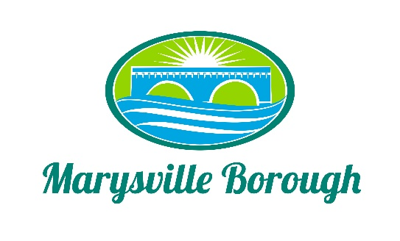

Parks and Recreation Minutes
February 7, 2022
6:00 PM

The Park and Recreation Meeting was called to order at 6:30 pm on Monday, February 7, 2022 at the Marysville Borough Office. Present were council members Leigh Ann Urban, Charles Wentzel, Jackie Zulli and Borough Manager Zachary Border,

New Business

- Elect a Chair
The Committee nominated Charles Wentzel as Chair and with no other nominations he accepted and was appointed as Chair

- Kristie Smith Perry County Conservation District
Kristie discussed and Earth Day Celebration that will be held on April 23 at the Clarks Ferry Traven. There will be food and vendors and much more.

- Pump Track
Mike from the Susquenita Mountain Bike Team wanted to discuss installing a pump track at the Lions club. Mike described what a pump track was and what type tracks there are. The committee really liked the idea but did not think it would work at the lions club portion of the park that the borough owned but they suggested reaching out to a private land owner to see if they would be willing to help out with the track.

- Pool Manager
The Committee discussed the opening of the pool manager position Rich Stees was as the meeting to go over the responsibilities of the pool manager and the committee directed Zach to advertise for the position.

- Pool Employee Salaries
The committee decided to refer this to the finance committee

- Award or other recognition for those involved in the bridge drop

The committee directed Zach to draft a letter for all of council to sign that thanked all who were involved with the bridge drop.

- Update on Grant Discussion with County / Penn Strategies
Zach Leigh Ann and Greg met with the Grant writes at Penn Strategies to discuss grant opportunities with for Parks and Rec and some of the suggestions were to apply for the trails grant again as well as a DCNR grant for a parks masterplan.

Old Business

- Greenways, Trails and Recreation Grant Program
Zach informed the committee that the borough did not receive this grant only nine awards were given out in the entire state and none were in perry county.
- Hoverter Grant
The borough did not receive any grant money from the foundation based on the fact that the foundation felt that since the borough was not a nonprofit and had other ways to obtain the funds for the playground improvements

- CDBG Grant
Zach informed the committee that this was still being reviewed by CDBG.

- Future Pool fundraisers
No Discussion

- Plant a new tree to decorate for Christmas
No Discussion
Tabled Items
Pool Parking Lot, Family Fun Night, Flea Market, Food Trucks, and Vendors were all tabled to a future meeting

