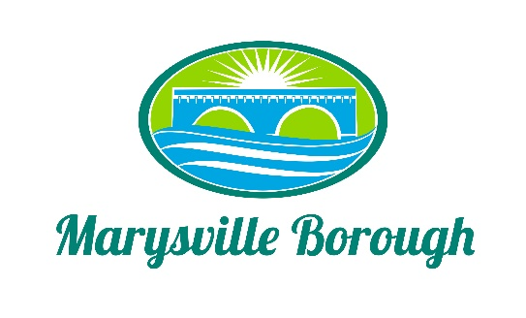

Parks and Recreation Minutes
March 7, 2022
6:00 PM

The Park and Recreation Meeting was called to order at 6:00 PM on Monday, March 7, 2022 at the Marysville Borough Office. Present were Committee Members Leigh Ann Urban and Dave Magee who was sitting in for the absent Jackie Zulli. Also present was Borough Manager, Zachary Border.

New Business

- Approve Minutes from the Previous Meeting

Since there were only two members and no quorum, the minutes were not voted on.

- Playground Equipment

Tabled.

- Newsletter
Leigh Ann did say she would continue to do the Newsletter until we can get another staff person on board to take over the responsibility.

- Half Price Pool Memberships
The Committee decided to recommend to the Finance Committee extending half price membership until July.

- Marysville Kayaking Trip
Tabled.

- Pool Membership for the Fire Department Raffle
Dave and Leigh Ann did have discussion about this and it was decided to move this to the Finance Committee for further discussion.

Old Business

All Items were tabled under Old Business.

Tabled Items
Pool Parking Lot, Family Fun Night, Flea Market, Food Trucks and Vendors are tabled items until future meetings.

