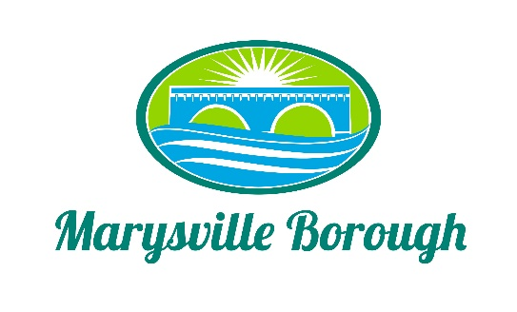

Parks and Recreation Minutes
April 4, 2022
6:00 PM

The Park and Recreation Meeting was called to order at 6:00 PM on Monday, April 4, 2022 at the Marysville Borough Office. Present were Chair, Charles Wentzel and Committee Members Leigh Ann Urban and Jackie Zulli who was present by phone. Also present was Borough Manager, Zachary Border and Borough Engineer, Greg Rogalski.

New Business
- Approve Minutes from the Previous Meeting
A motion was made by Leigh Ann and seconded by Jackie to approve the minutes from the previous meeting. The vote was unanimous.
- Playground Equipment
Due to not getting a few grants last year, the Committee discussed that it maybe time to just purchase some equipment. Charles had sent a link that showed a few of the pieces that he had found. There were two types of musical equipment and two types of playground equipment. Leigh Ann suggested making the purchase in pairs, doing the two musical instruments first and then the playground equipment. The Committee agreed and asked Zach to have the pricing for the next meeting.
- Newsletter
Zach brought a proposal from Messiah Print Shop to produce the newsletters. The Committee decided they wanted to stick with what they had since it was in the county.
- Lions Club MS4 Plan Update
There was some more discussion on the recreation part of the plan and Greg was able to provide more details of what was included in the updated plan.
- Neighborhood Shade Trees and Establish a Park in the Open Space of Rockville
This was part of the discussion that had to do with the Perry County Comp Plan and coming up with statements that the Borough would like included in the initial discussion of the plan.
Old Business
All the items under Old Businesses were tabled.
Tabled Items
Pool Parking Lot, Family Fun Night, Flea Market, Food Trucks and Vendors were tabled.

Other Business
There was no Other Business
Public Comment
There was no Public Comment

Next Meeting May 2, 2022

