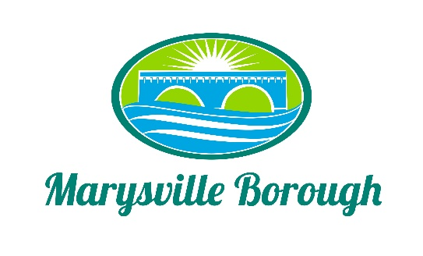

Parks and Recreation Minutes
May 2, 2022
6:00 PM

The Park and Recreation Meeting was called to order at 6:00 PM on Monday, May 2, 2022 at the Marysville Borough Office. Present were Chair, Charles Wentzel and Committee Members Jackie Zulli and Dave Magee who was sitting in for Leigh Ann Urban. Also present was Borough Manager, Zachary Border.

New Business

- Approve Minutes from the Previous Meeting
The minutes were looked at and approved.

- Playground Musical Equipment
The Committee asked Zach to print off copies of the survey that were done to show what the residents wanted the focus to be, as far as recreation items and music equipment came in last. The Committee decided to refocus priorities and look at the mulch and ADA swings and how to best use the money that was budgeted plus any grant money that would come in.

- Cameras at the Pool
Zach brought a quote to the Committee for getting cameras at the pool to help with safety and security. The Committee decided it was worth the investment and instructed Zach to move forward with the purchase.

- Parking at the Pool
During the clean up around the pool there was a notable amount of garbage. Zach asked the Committee to write a letter to Specialty Baker’s asking them to no longer park in front of the pool at any time, even the offseason. The Committee did not want to damage any kind of relationship with the bakery so they suggested just reaching out and reminded them to clean up after themselves.

Old Business

- Greenways, Trails and Recreation Grant Program
The County Grant Writer is assisting the Borough in writing this Grant. It is due by May 31st.

- CDBG Grant
This grant was approved and the Borough is now waiting on DEP to provide a permit for us to do the work over the creek.

- Future Pool Fundraisers
This was discussed and talked about. The lack of staff would make it difficult to run a fundraiser out of the office.

- Plant a New Tree to Decorate for Christmas
Dave was going to look into if the Borough could get a tree donated so that it could be decorated and have as a community event.

- DCNR Grant
This grant was submitted for Recreation projects.

