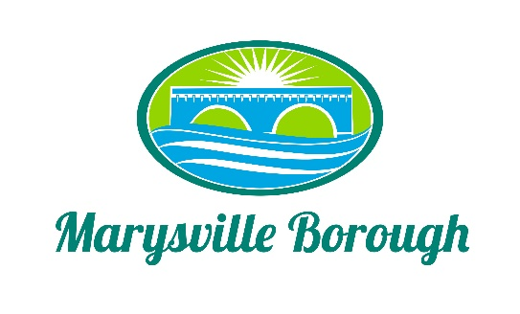

March 22, 2022

AGENDA

WORK SESSION None

PUBLIC MEETING Call to Order at 7:30 PM

Introduction of Visitors and Roll Call of Members and Staff.
Stephanie Stoner _____ Jason Finnerty, County Planner Staff _____
Jennifer Brock _____ Greg Rogalski, Borough Engineer _____
Robert Zimmerman, III _____ Charles Wentzel, Council Liaison _____
Julie Walter _____

- Minutes
- February 22, 2022.

- Public Comment – Please Keep to a Three (3) Minute Time Limit.

- Old Business

- New Business
- Perry County Comprehensive Plan – Goals & Objectives.

- General Announcements

7. Report on Borough Council Meeting and Borough Manager Update.

8. Public Comment – Please Keep to a Three (3) Minute Time Limit.

9. Adjournment

Next Workshop Meeting Date: April 20, 2022

Next Meeting Date: April 26, 2022

