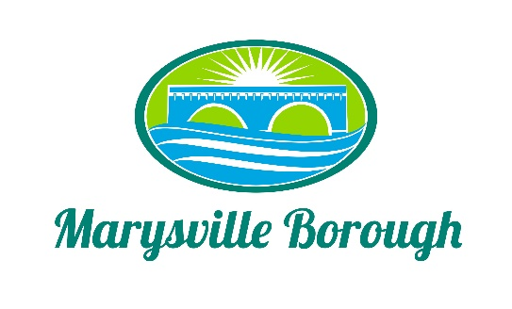

August 23, 2022

AGENDA

WORK SESSION None

PUBLIC MEETING Call to Order at 7:30 PM

Introduction of Visitors and Roll Call of Members and Staff.
Jennifer Brock _____ Jason Finnerty, County Planner Staff _____
Stephanie Stoner _____ Greg Rogalski, Borough Engineer _____
Scott Artley _____ Charles Wentzel, Council Liaison _____
Julie Walter _____
Robert Zimmerman, III _____

- Minutes.
- February 22, 2022.
- March 22, 2022.
- May 24, 2022.

- Public Comment – Please Keep to a Three (3) Minute Time Limit.

- Old Business:

- New Business:
- Review Perry County Comprehensive Plan.

- General Announcements.

6. Report on Borough Council Meetings.

7. Public Comment – Please Keep to a Three (3) Minute Time Limit.

8. Adjournment.

Next Workshop Meeting Date: September 21, 2022

Next Meeting Date: September 27, 2022

