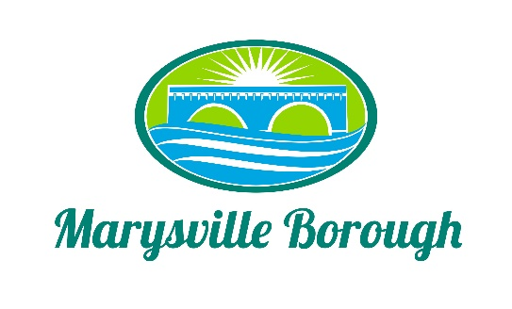

September 27, 2022

AGENDA

WORK SESSION None

PUBLIC MEETING Call to Order at 7:30 PM

Introduction of Visitors and Roll Call of Members and Staff:
Jennifer Brock _____ Jason Finnerty, County Planner Staff _____
Stephanie Stoner _____ Greg Rogalski, Borough Engineer _____
Scott Artley _____ Charles Wentzel, Council Liaison _____
Julie Walter _____
Robert Zimmerman, III _____

- Minutes.
- August 23, 2022

- Public Comment – Please Keep to a Three (3) Minute Time Limit

- Old Business:
- Review Perry County Comprehensive Plan as it Relates to Marysville Borough

- New Business:

- General Announcements

6. Report on Borough Council Meetings

7. Public Comment – Please Keep to a Three (3) Minute Time Limit

8. Adjournment

Next Workshop Meeting Date: October 19, 2022

Next Meeting Date: October 25, 2022

