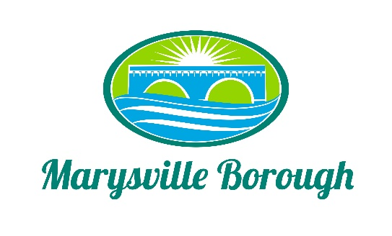

COUNCIL MEETING AGENDA
December 12, 2022
6:00 PM Work Session
- Golf Carts on Borough Roads
- Sherriff Sale
7:00 PM Borough Council Meeting
1. Pledge of Allegiance
2. Moment of Silence
3. Roll Call

Lance Barthel ______ Richard Chorba, Treasurer ______
John Edkin ______ Zachary Border, Borough Manager ______
Dave Magee ______ Trish Hammaker, Secretary ______
Leigh Ann Urban ______ Dan Altland, Solicitor ______
Brian Webster ______ Greg Rogalski, Borough Engineer ______
Charles Wentzel ______
Jacquelyn Zulli ______
Michael McCreary, Mayor ______

4. Consent Items
- Approval of 11/14/2022 and 11/22/22 Minutes
- Approval of Financial Statement
- Approval to Pay Bills
5. Public Comment (Please Keep to a Three (3) Minute Time Limit)
6. Engineer’s Report
a. MS4

7. Old Business
a. South Main Street Bridge Project
b. Cameras for Public Works Complex
I Alwine
II DGL

8. New Business
a. Motion to approve resolution number 354 setting the borough tax rate for 2023
b. Motion to approve the 2023 Budget
c. 2023 Meeting Schedule
d. Motion to approve ordinance number 644 in regard to Act 57
e. Motion to approve the agreement with Pennoni for Lions Club Park PRP Project – Final Design and Permitting

f. Motion to approve the quote from 911 Rapid Response to decal the 2018 explorer in the amount of $1650.00

9. Commission Reports
a. Planning Commission Report
b. Code Enforcement Officer’s Report
c. Police Department Report
d. Fire Company Report

10. Committee Reports
- Personnel
- Finance
- Sewer/Sanitation/Streets
- Parks & Rec and Pool
- Managers’ Report

11. Correspondence
12. Public Comment (Please Keep to a Three (3) Minute Time Limit)
13. Media Questions

Next Scheduled Meeting will be on: January 9, 2022

