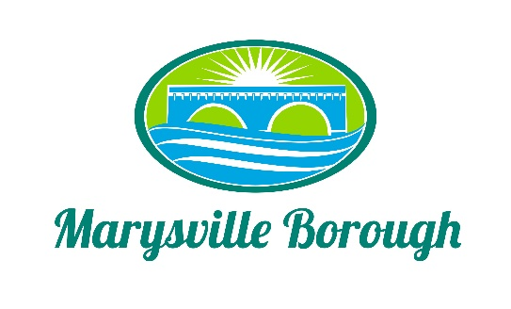

Marysville Borough
Finance Committee Agenda
December 7, 2022
5:30 PM
Chair: Charles Wentzel Member: Leigh Ann Urban and Brian Webster
New Business
- Approval of November minutes
- Electronic Gate
Old Business
- 2022 Budget
- 2023 Budget
Public Comment

