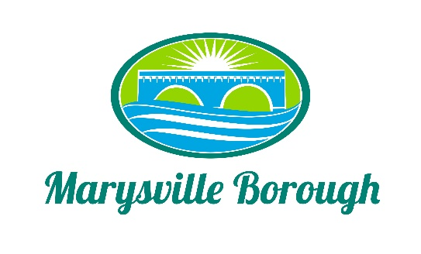

Marysville Borough
Finance Committee Agenda
May 3, 2023
5:30 PM
Chair: Charles Wentzel Members: Brian Webster & Scott Artley
New Business
- Approval of Last Meeting’s Minutes
- Aqua-Aerobic Systems Invoice 7/2022
- Aqua-Aerobic Systems Proposal
- Locust Village Invoice
- Insurance Quote for Police Officer’s Spouse
Old Business
- PLGIT Investment
Public Comment

Next Meeting June 7, 2023

