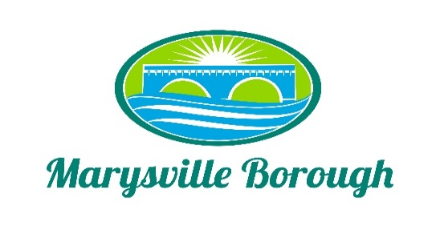

Finance Committee Agenda
March 8, 2023 5:30 p.m.
Councilmember Chair Charles Wentzel, Councilmembers Brian Webster, and Leigh Ann Urban.
Old Business
1. Approval of February 8, 2023 minutes
New Business
1. Sewer and Trash
To change Option from Quarterly to Monthly billing. All new builds and properties purchased will be billed on a Quarterly Billing Cycle.

2. Streets Committee
a. Developing regiment of projects for repair to roads, repaving, etc. to be completed throughout the year(s). Need to arrange funding for these ongoing projects. Funding
available for 2023.
b. Funding for repairs to road near Roger Barrick’s property.

3. Sale of Scrapped Skid Steer
Allocation of this money.

4. Pool
At this time, we have 5 lifeguards interested in returning, 8 guards would be a minimum, and 10 guards would be more realistic. Base pay for beginning guards is $10.30, and other local rates for entry level jobs
are higher now. After discussion, the committee
agreed that a 15% increase in all hourly wages would be reasonable,
which would increase base pay for beginning guards to $11.85. This should also be accompanied by a 15% increase in all membership rates as well as a roughly 15% increase in
daily pass rates.

5. Proposal for Audit of Financial Statements
Approval of the proposal for the audit of the financial statements of Marysville Borough for the years ending December 31, 2022, 2023, 2024, and 2025 from Boyer & Ritter LLC.

6. The Stormwater Authority would like to recommend to Council that a Stormwater Fee
be implemented to help cover the cost of the MS4 requirements issued by the State
and Federal government. The Authority recommends that the fee be set at $38 per quarter per parcel for a term of 4 years, to be reviewed in 2 years.

Public Comment

