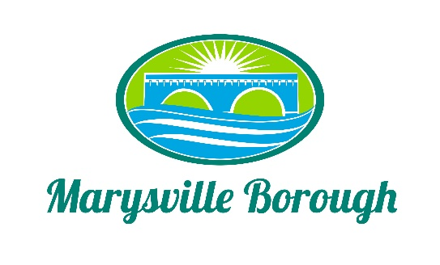

Streets Sewer and Sanitation Meeting Agenda
December 5, 2022
2:15 PM

Chair: Jackie Zulli Members: Lance Barthel John Edkin

New Business

- Review of the November Minutes
- Golf Carts on Borough Streets
- Water runoff on Overcrest

Old Business

- Trash Contract
- Sheriff Sale

Other Business

Public Comment

Next Meeting

