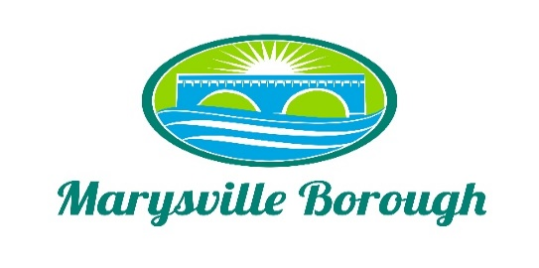

Parks and Recreation Agenda
December 5, 2022
6:00 PM
The Park and Recreation Meeting was called to order at 6:00 PM on Monday, December 5, 2022, at the Marysville Borough Office. Present were Chair, Charles Wentzel and Committee Members Jackie Zulli and Leigh Ann Urban, and Borough Manager, Zachary Border.

New Business

- Review November Minutes
The Minutes were reviewed and approved

- Pool (sand, trash)
Zach said he had one quote for the new sand filter, but wanted to find a few others then bring them back to the Committee at the next meeting.

- Playground Redesign (Steve Hemler)
Steve Hemler from General Recreation went over some of the things we could possibly do with the DCNR grant money and to talk about the overall safety of our parks.

- Lions Club Park Bridge (SEDA-COG)
Members of SEDA-COG attended the meeting to discuss the grant money that was given for the bridge project and how to move forward since we only received one bid and it was way above the amount that we had for the grant. The thought was to move the project in-house to try to give it a way from having to be bid and take more time from the project. Greg and Zach were going to get together to discuss options. The money needs to be used by May 2023.
Old Business

- Grant Updates
No Updates

Tabled Items
No updates on tabled items

