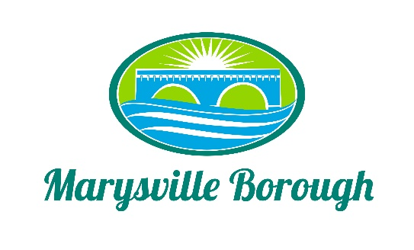

Finance Committee
March 8, 2023
The Finance Committee meeting was called to order at 5:30 PM on Wednesday, March 8, 2023 at the Marysville Borough Office. Present were Councilmember Chair Charles Wentzel and Councilmembers Brian Webster, and Scott Artley. Mr. Artley filled the vacancy of Leigh Ann Urban who resigned effective March 8, 2023.
New Business
- Approval of February minutes
The minutes were not available and will be traced for the next meeting.

COMMENTS
- Lance Barthel
a. Sale of the Scrapped Skid Steer. What account should money be placed? Councilmember Webster felt it could be used for 2b. on the agenda. He felt we were taking other money to pay for the new Skid Steer. Approximately $10,000.00 of it could be used to repair the road near Roger Barrick’s property because it is a sewer easement. Monies from the sale will be divided 50% Sewer and 50% General. Monies will be deposited into the transfer account, then the holding account, and then divided into the two funds.
b. The Pool. Discussion followed for all the 2023 Pool Employees’ Salaries for Manager, Lifeguards, and Concessions. At this time, we only have 5 Lifeguards interested, 8 would be a minimum, and 10 would be more realistic. Specific duties and job descriptions were discussed. Laura will be given her own email account. She must be Certified for the operation of the Pool. Head of Concession handles ordering and manages food, etc. The Committee thought Laura registered, but not sure whether she tool the course. The Committee compared Little Buffalo and other pools in the area. Included with these minutes are the proposed salaries for Council’s approval to be able to advertise next Tuesday. Rich Stees was called during the meeting to answer questions. He was consulted and is going to attend the Council Meeting and the Work Session. Members are searching for the Walkie Talkies and other equipment from last year. If they are damaged, we may need to purchase new ones. After Mr. Barthel left Membership prices were discussed and included with this packet and for Council’s approval. Concession prices should be able to help with the costs of the salaries.
c. Proposal for Audit of Financial Statements. Asking for the approval for the proposal for the Audit of the Financial Statements of Marysville Borough for the years ending December 31, 2022, 2023, 2024, and 2025 from Boyer & Ritter LLC. Michelle, our Contract Accountant felt this was a good price.

d. Quantum Accounting Associates. Began reconciling our books this week which it is a huge undertaking. They also felt the proposal from Boyer & Ritter LLC was good.

e. 2023 Trash Company Bids. All the Committee members received a copy of the REP’s and it will need to go out by next Tuesday or as soon as possible. The companies need at least 2 months to set a route, etc. after the award is given, the last time it was more like 2 weeks. The effective date will be September 1, 2023.

Council President left the meeting and the Committee resumed the regular agenda.

1. Sewer and Trash
The Committee tabled the request for the change to remove the Option to change from Quarterly to Monthly.

2. Streets Committee
Council asked for funding to be provided for projects for repair to roads, repaving, etc.
throughout the 2023 year. There is a need to arrange funding for these ongoing projects.
The Finance Committee requests a specific list be provided as well as the amount of monies available in the Budget. This a generic request with no specifics. The Committee in fact does not even have a copy of the “to date” expenditures they must work with.

Next scheduled Finance Meeting is April 5, 2023

