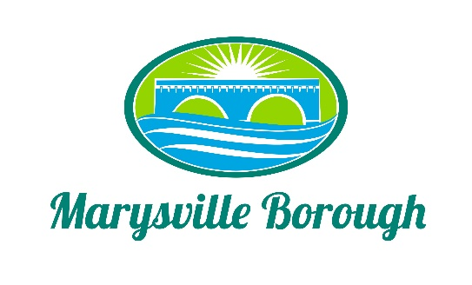

Finance Committee
April 5, 2023
The Finance Committee meeting was called to order at 5:30 PM on Wednesday, April 5, 2023 at the Marysville Borough Office. Present were Councilmember Chair Charles Wentzel and Councilmembers Brian Webster, and Scott Artley.
New Business
- The Finance committee made no recommendation for pay or benefits changes for staff.

- Certificate of Deposit. There is a $500,000 certificate of deposit that is part of general fund money which is coming due in mid-April. Committee members reviewed the current balance of the accounts in the general fund, as well as relative interest rates. Consideration was given on the possibility of loaning some of that money to MS4, so that the loan interest is paid to the borough rather than to a bank. However, a 90-day CD timeline (due July) may still allow for that possibility. Ultimately, the committee recommends Council should roll the CD and interest into another 90-day CD when it comes due. This decision item should be put onto the Council agenda.

- Streets committee has requested funding for road repair and repaving for this year. Action on this item was tabled until we have a better assessment of our current finances.

The committee will reconvene on Wednesday, April 26 at 5:30 pm.

