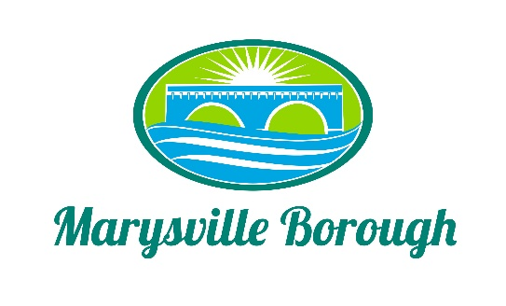

Finance Committee
December 7, 2022
The Finance Committee meeting was called to order at 5:30 PM on Wednesday, November 9, 2022 at the Marysville Borough Office. Present were Councilmember Chair Charles Wentzel and Councilmembers Brian Webster, and Leigh Ann Urban. Staff members present were Borough Manager, Zachary Border.
New Business
- Approval of November minutes
The minutes were not approved and needed to be reworked for the next meeting.

- Electronic Gate
This was an item to be brought back at the end of the year to see where the budget stood. There was interest in the gate but the committee wanted to see some different options. Borough Manager Border would take it back to the gate company and come back to the Committee with different quotes.

Old Business
- 2022 Budget
There were a few questions asked by the Committee about bills that were answered by Mr. Zach.

- 2023 Budget
No changes to the 2023 budget it was ready to be approved by the full Council.

