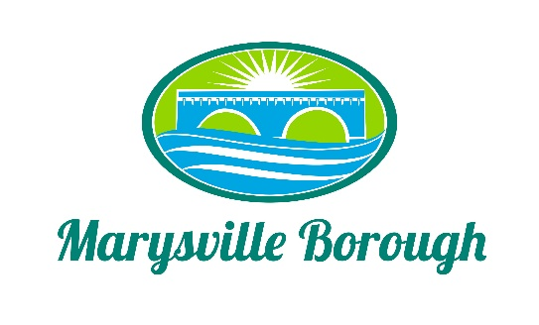

Stormwater Authority
December 5, 2022

The Marysville Stormwater Authority Meeting was called to order at 5:00 PM on Monday, December 5, 2022 at the Marysville Borough Office. Present were Authority Chair Leigh Ann Urban, Members Charles Wentzel, Dave Magee, Terry Kline, and Jackie Zulli. Also, present Borough Manager, Zachary Border and Borough Engineer, Greg Rogalski.

New Business

- Review of November Minutes
A motion was made by Terry and seconded by Dave to approve the November Minutes.

- Fee Study update
Greg and the Commission had an extensive discussion on what a fee would look like. Greg stated now would be the time for the Commission to really start to zero in on a number so that the Commission can see how that would affect each household. There was also discussion on credits and how that policy would look along with how this will affect churches and other non-profits. Greg will come back to the meeting in February with scenarios to help the Commission move forward.

Old Business

- Locust Village Update
The bid was approved by Council and so the next step was getting the construction company in place to start the work.

- Lions Club Pond/Design Fees
Greg was going to provide a separate agreement to be approved by Council to deal with the pond project.

