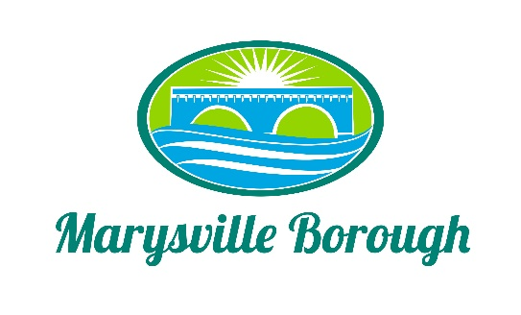

Streets, Sewer, and Sanitation
Meeting Minutes
March 6, 2023
2:15 PM

The Streets, Sewer and Sanitation Committee meeting was called to order at 2:15 PM on Monday, March 6, 2023 at the Marysville Borough Office. Present were Council President Lance Barthel and Councilmember John Edkin. Also present were Borough Engineer, Greg Rogalski, Maintenance Workers, Ken Miller and Rob Laman, and Sewer Plant Operators Lonnie Sarver and Peter Boele.

Old Business
- February 2023 Minutes
Approved
New Business
1. New Trash Contract
The proposed bid for 2023 will be reviewed by Council the evening of March 13, 2023. A copy was emailed to all Council Members.

- Streets
a. Develop an ongoing regiment of projects for repair to roads, repaving, etc. to be completed throughout the year(s).
b. Work with the Finance Committee to project funding of said roads.
c. Repairs to road near Roger Barrick’s property.

- Drainage of Water
a. Greg Rogalski reviewed plans with Attendees regarding runoff on Overcrest Road. A Swale could be used for the stormwater issue. The Borough will work with Patty Copp and Mrs. Spease’s (Laurie) properties.
b. Park Drive end wall needs size R8 rocks to help with drainage. Since E.K Services are doing work in that area, they may be able to help with the placing of the rocks. We will get estimates for the necessary work.

4. Sewer Plant
Lonnie Sarver requested approval to purchase approximately $700.00 in repair parts for the Wrench in the Sewer Plant. It is about 25 years old and these parts will keep the operation running vs. a replacement.

5. Sewer Plant and Maintenance Building
Main Door – panic door does not close or latch properly once it is opened. The wind blows it open and sets off the alarm. Since Baker Door Company is still working on the doors for the Sewer Plant, they will be asked for an estimate to replace and/or repair.

Other Business
None
Next Scheduled Meeting will be April 3, 2023 at 2:15 p.m.

