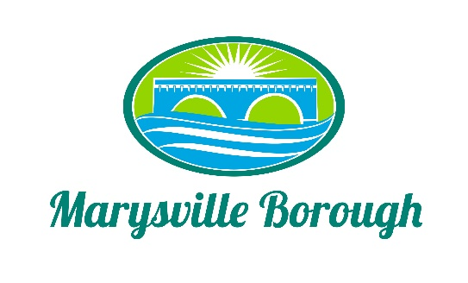

Marysville Stormwater Authority
Stormwater Fee Informational Session Minutes
April 17, 2023
The Marysville Stormwater Authority Informational Session was called to order at 6:30 PM on Monday, April 17, 2023, at the Marysville Lion’s Club. Present were Dave Magee, Terry Kline, Committee Member Charles Wentzel, Administrative Assistant Haley Briner, and Borough Engineer Greg Rogalski.

Greg Rogalski presented a PowerPoint presentation where he went over the following topics.

- What is MS4 – Municipal Separate Storm Sewer System- we had to separate the sewage from the main stormwater drains in the borough.
- MS4 Requirements
  - Minimum Control Measures
- Stormwater Ordinance Requirements
- 2017 Pollutant Reduction Plan Report
- Proposed Capital Projects
  - Storm Interceptor SNOUT
  - Locust Village Infiltration Basin
  - Lions Club Park Extended Detention Basin
  - Cameron Street Vegetated Swale

- Project Schedule and Cost
  - Lions Club Park & Cameron Street: 2024
  - Budget - $1,000,000 for the upcoming projects.

- Formation of Stormwater Authority- To administer dedicated fee
- Stormwater Fees – Equivalent Residential Unit (ERU) - 3,560 S.F.
  - Residential - $38 (Proposed)
  - Non-Residential – ERU Based
  - Credits- to be determined.

- Public Comment (3 Minutes max.)
Jennifer- Asked why we didn’t calculate the railroad’s fee into our numbers.
Greg- We didn’t include their stormwater rate in our fee structure so that we didn’t underbid ourselves.
Jennifer- Also wanted to know if there was going to be a discount for retired people and how long the fee would be in effect.
Greg- explained that we plan to reevaluate the fee schedule in two-four years because of the large number of projects to happen & more residents to be moving into Rockville Estates, which will impact the fee.

Randy Kenny- mentioned that there aren’t any silt fences in the Rockville Estates development.
Greg- informed him that they utilize sediment traps because it’s a large-scale construction site.
Randy Kenny- Raising Pipe in Pond will flood the baseball fields more.
Greg- explained that it’s not going to be permanently raised, it’s for the management of smaller rain storms.

Justin Hughs- What is the current pollution rate we must reduce to be in compliance?
Greg- The explanation is available in the Pollution Reduction Plan, available at the Marysville Borough Office.

Justin Heffelfinger- President of Lion’s Club was also concerned about the pond level & how it will impact the fields.
Greg- reassured him that the Pond water level will not be raised permanently.

Dan Stephens- stated that the Borough Office Building & Locus Villages are both built on previous biohazard landfill sites.

John Edkin- asked if residents will have to pay if their property is vacant.
Charles- Yes.
John Edkin- wanted to know how the fee would be applied to a deeded property with multiple addresses.
Dave- explained that if there’s one deed for a property, it would be billed one Stormwater Management Fee even if there are multiple addresses.

Valley Hill Association- Mentioned that they have a retention pond and wanted to know if there were going to be credits given for this and if we are billing the residents.
Charles- Credits have yet to be discussed. We intend to bill the owner(s) of the property.

Jennifer- Asked if we’ve applied for any grants.
Dave- We haven’t seen any grants yet for MS4 specifically but informed us that Representative Perry Stambaugh & Senator Greg Rothman’s offices will be looking to send them our way in the future.
