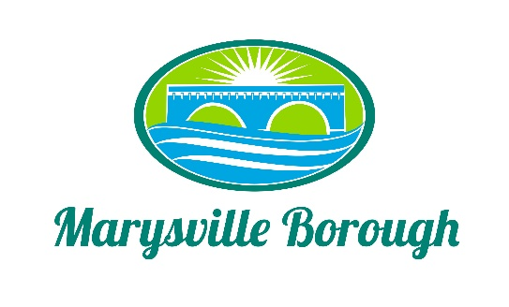

Streets, Sewer, and Sanitation Committee
December 5, 2022

The Streets, Sewer, and Sanitation Committee meeting was called to order at 2:15 PM on
Monday, December 5, 2022 at the Marysville Borough Office. Present was Jackie Zulli, Committee Chair, and Committee Members Lance Barthel, John Edkin. Also, present were
Sewer Operators Lonnie Sarver, Pete Boele; Maintenance Worker Rob Laman, Borough
Engineer, Greg Rogalski, and Borough Manager, Zachary Border.

New Business

- Review of the Minutes
The Minutes were reviewed and approved with no corrections.

- Golf Carts on Borough Streets
This was brought to the streets committee because of complaints of golf carts on the road. The committee discussed coming up with an ordinance not just for golf cars, but for other kinds of vehicles as well. This was referred to the Council Work Session for more discussion.

- Water Runoff on Overcrest Road
Patty Copp came to the November Borough Council Meeting and asked if there had been any discussion about the flooding she receives in her yard from heavy rain storms. This was then referred to the Streets for further discussion. Greg stated he would talk with Mrs. Copp to see the best way for her issue to be resolved.

Old Business

- Trash Contract
This was an item to stay on the agenda so the Committee Members can start to develop a bid for the spring.

- Sheriff Sale
Councilmember Barthel wanted some more information before we started to move forward with Sherrif sales and ask that the Solicitor provide a definition for the types of sales that occur for delinquencies.

