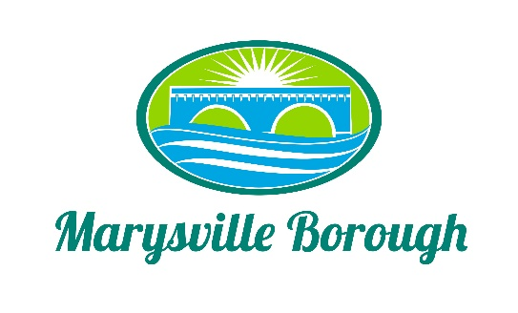

Streets Committee Minutes
September 7 2021
1:30PM

The Streets Committee Meeting was called to order at 1:30 pm on Tuesday September 7 2021 at the Marysville Borough Office. Present were Council members Steve Copp Leigh Ann Urban and Dave Magee Also, present was, Borough Engineer Greg Rogalski, Maintenance Worker Ken Miller Rob Laman and Borough Manager Zachary Border

Trucks/Equipment:

New Business

- Removing the 4-hour parking Ordinance from the Square

The committee felt the 4-hour parking signs should go back up. They feel if the signs are removed it would hurt the businesses. This this was to be an informational point at the council meeting.

- No Parking Both side from Verbeke to South State Road

Zach explained there were a number of complaints about cars parking on the north side of Lansvale Street and causing a potential hazard for vehicles turning onto Lansvale from 11/15. The committee agreed to send this to council for approval.

- 902 – Recycling Program Development and Implementation

Zach discussed a recycling grant program that could help the borough purchase a new leaf vacuum and box the grant would cover 90 percent and the borough would have a 10 percent match. The committee liked the idea and recommended this to the finance committee to find the money for the match.

Old Business
- South Main Street Bridge Project
The committee discussed the evaluations that were done by the committee members and the consultant. The committee decided to move the discussion to work session for further discussion.

2. Pole Building

The committee discussed the cost and location but still feel at this time that no action should be taken.

