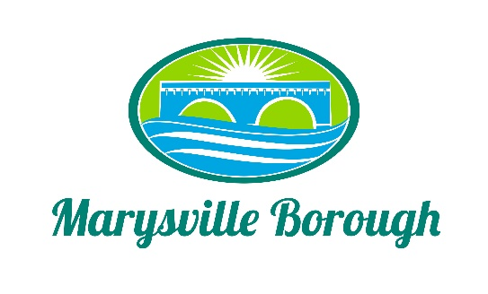

Streets Committee Minute
November 1 2021
1:30PM

The Streets Committee Meeting was called to order at 1:30 pm on Monday November 7 2021 at the Marysville Borough Office. Present were Council members Steve Copp Lance Barthel and Dave Magee Also, present was, Borough Engineer Greg Rogalski, Maintenance Worker Ken Miller Rob Laman and Borough Manager Zachary Border

Trucks/Equipment:

New Business

- Making Lansvale one way
Council had referred back to the streets committee to look at making a section of lansvale one way. There was discussion on how it would affect plowing and flow of traffic. No recommendation was made so it was sent back to council to make a decision

- Leaf Collection Facility
Zach Ken and Rob had a meeting with DEP to discuss getting a permit to store the borough leaves Zach is going to apply for the permit then DEP will come out to inspect the facility

Old Business

- South Main Street Bridge Project

Zach is working on finishing the rankings and working on getting to the point where the engineer can be named

- Pole Building
No Discussion

