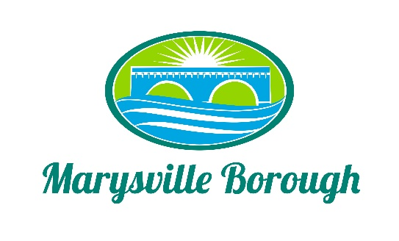

Sewer & Sanitation Meeting Minutes
September 7, 2021
2:15 PM

The Sewer & Sanitation Committee Meeting was called to order at 2:30 pm on Monday, August 2, 2021 at the Marysville Borough Office. Present were Chair Steve Copp council members Dave Magee and Lehigh Ann Urban, Borough Manager Zachary Border, Borough Engineer Greg Rogalski, Sewer Operators Lonnie Sarver and Pete Boele

New Business

- 90-Gal Flammable Cabinet Self Closing Safety Cabinet Door.

The borough safety committee recommend a cabinet to be able to store all gas cans already filled. The committee liked the idea but wanted to see other prices so they asked staff to get some more pricing and bring it back next month.

- Trailer Park

With the recent high rains and issues the borough had at the pumping station. The committee wanted investigate if the trailer park added to any of the overflow. Pete and Lonnie will have test the flow to see where its coming from.

- Pump Station 3

With the recent high rains, the pumping station was not able to keep up with the flow. A discussion was had with Greg on how to fix the problem. Greg said that when it’s a normal flow everything works the way it should. The issue occurs when the flow is higher, so a bigger pump may be needed. The committee also discussed the issue with sewage backing up into the house at 222 South State Road. The committee decided to move forward with the check valve and have staff install it. The borough will create an agreement with the home owner saying he is responsible for the maintenance.

- 236 Park Drive

There is a sink hole on Park Drive. This is caused by a broken lateral that is the home owners’ responsibility to fix. The home owner is concerned about the cost of the project.

Zach invited him to the committee meeting to see if council would be willing to help at all with the cost. The property owner did not show up so Zach will continue to purse him getting the line fixed.

Old Business

- Delinquents

The was just an FYI item for the committee.

