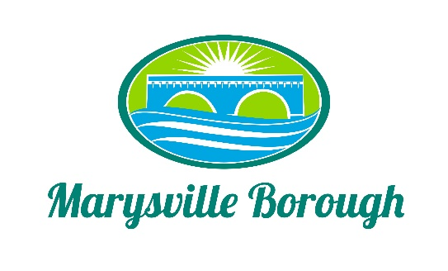

Sewer & Sanitation Meeting Minutes
November 1, 2021
2:15 PM

The Sewer & Sanitation Committee Meeting was called to order at 2:30 pm on Monday, November 1, 2021 at the Marysville Borough Office. Present were Chair Steve Copp council members Dave Magee and Lance Barthel, Borough Manager Zachary Border, Borough Engineer Greg Rogalski, Sewer Operators Lonnie Sarver and Pete Boele

New Business

- Cleaning the Wet Well
Lonnie and Pete discussed how the wet wells have not in cleaned in over 5 years and the more maintenance that is done the longer the equipment will last this was sent to finance committee to discuss

- Roof Repair
Zach discussed the quote that was given to patch the roof and the warranty. Lance wanted to know if the brough did not get the service plan and the guys went on the roof and did upkeep would the warren be voided Zach will check and this was referred to finance.

- Vacant Rate
At the last council meeting there was discussion fhe public about the way the vancant rate was done the committee decided t just remind people that they can fill out there form online or bring it to the office

- Sewer Billing

This was a discussion on how to bring the sewer billing current Zach reached out to muni-link and the only way they could do that would be to do a free month of billing or add a double charge. The committee decided to just do things the same way.

Old Business

- Delinquents

This was an FYI to the committee

- Pump Station 3
No new information

- Trailer Park

The flow meter will be installed in November

