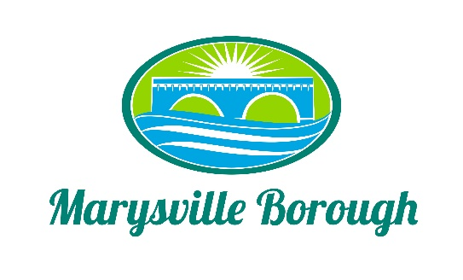

Sewer & Sanitation Meeting Agenda
December 6, 2021
2:15 PM

The Sewer & Sanitation Committee Meeting was called to order at 2:15 pm on Monday, December 6, 2021 at the Marysville Borough Office. Present were Chair Steve Copp council members Dave Magee and Lance Barthel, Borough Manager Zachary Border, Borough Engineer Greg Rogalski, Sewer Operators Lonnie Sarver and Pete Boele

New Business

- Lateral Ordinance

There was discussion on if the lateral ordinance needed to be changed the committee wanted me to reach out to Dan for more information.

- Park Drive Update

The committee decided to move forward with repairing the broken lateral and to use Rogel and to recommend this action to council

Old Business

- Delinquents

This was just an informational item

- Pump Station 3
There was no new information on this item.

- Trailer Park
Zach informed the committee that the trailer park would be doing a complete rehab of their sewer system. This could be removed from the agenda.

