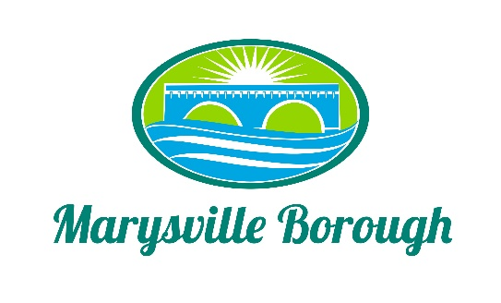

Streets Sewer and Sanitation Meeting Minutes
February 7, 2022
2:15 PM

The Streets, Sewer and Sanitation Committee meeting was called to order at 2:15 PM on Monday, February 7, 2022 at the Marysville Borough Office. Present were Council members Jackie Zulli, Lance Barthel and Leigh Ann Urban. Also present were Borough Engineer, Greg Rogalski, Maintenance Workers, Ken Miller and Rob Laman and Borough Manager, Zachary Border .

New Business

- Election of a Chair
The Streets, Sewer and Sanitation Committee nominated Jackie Zulli as the Chair and she accepted and was appointed.

- Mailbox Damage
Manager Border Brought before the Committee a policy question about what the Borough would do if a mailbox was damaged by a plow truck. The committee decided that if it was damaged, it should be replaced by the Borough.

- Traffic Light Box
Zach updated the Committee on the damage done to the traffic light control box. A claim was submitted to the insurance company as the cost of a new box would be between $10,000 and $12,000.

- Heaters in the Sewer Building
Zach presented a quote to fix or replace the heaters in the Sewer Plant. Right now, the building is being heated by small space heaters. The Committee instructed Zach to go out and find more quotes.

Old Business

- Lansvale One Way Traffic Study Update
Engineer Rogalski gave an update on the results of the Traffic Study. Greg advised the study concluded that the Borough is able to change the street to one way with no issues and that the next steps would be to submit to PennDOT.

- Pump Station 3
Greg did not have any new updates on this project.

Other Business
None

Public Comment
None

The Committee adjourned to go into an Executive Session with no further business at 3:00 PM.

