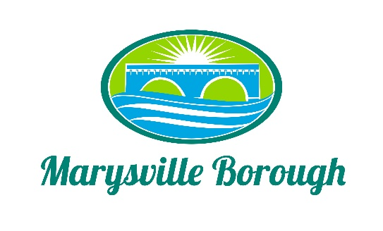

Streets, Sewer and Sanitation Meeting Minutes
March 7, 2022
2:15 PM

The Streets, Sewer and Sanitation Committee meeting was called to order at 2:15 PM on Monday, March 7, 2022 at the Marysville Borough Office. Present were Committee Members Lance Barthel and John Edkin. Dave Magee sat in for the absent Jackie Zulli, Committee Chair. Also present were Maintenance Workers, Ken Miller and Rob Laman, Sewer Operators Lonnie Sarver and Pete Boele and Borough Manager, Zachary Border.

New Business

- Approve Minutes from the Previous Meeting

Lance made a motion and John seconded to approve the Committee Minutes from February. The motion passed unanimously.

- Snow Emergency on the Square

The Committee decided to recommended to Council to add the square to the snow emergency route.

- Vacancy Rate Form

There was some discussion but the Committee felt no changes were needed.

- Actuator Instillation

The actuators were ordered in last years budget but this was the cost to install them and make sure the computer is able to talk to them so it operates correctly.

- Skid Loader

Maintenance was having a problem closing the latch on the skid loader but was able to get it fixed. Staff did reiterate that a new skid loader will be needed.

Old Business

- Lansvale One-way Traffic Study Update

The traffic study is now with PennDOT to review.

- Pump Station 3

There was no new information, but Dave did request that if we were able to do gravity fed instead of using the pump station, that was his preference.

- Heaters the Sewer Building
At the February meeting, the Committee asked to see more quotes. Zach presented one from X10 and the Committee wanted more time to research other options especially with the warmer weather coming up.

