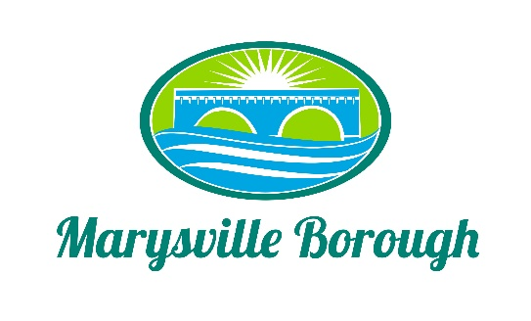

Streets Sewer and Sanitation Meeting Minutes
May 2, 2022
2:15 PM

The Streets, Sewer and Sanitation Committee meeting was called to order at 2:15 PM on Monday, May 2, 2022 at the Marysville Borough Office. Present were Committee Members Lance Barthel, John Edkin and Jackie Zulli, Committee Chair. Also present were Maintenance Workers, Ken Miller and Rob Laman, Sewer Operators Lonnie Sarver and Pete Boele, Borough Engineer, Greg Rogalski and Borough Manager, Zachary Border.

New Business

- Approve Minutes from the Previous Meeting
The Minutes were looked at and no corrections were needed.

- Automatic Gate
There were some concerns from members of Council about the gate at the Plant being left open so Zach brought a proposal from a fence company for an automatic gate. The Committee discussed the options and decided to send it to the Finance Committee to see if they could find the money.

- Storm Water Run Off on Overcrest
Zach was approached by a resident on Overcrest who, every time there is a lot of rain, all of the stormwater flows into her yard. The Engineer gave some options for a fix, specifically adding it to the Borough Stormwater Project behind the Borough Building. The Borough Engineer would like some different ways to tie it together.

- Leaf Collection/ Street Sweeping
There was discussion on changing the number of days that the Borough street sweeps and picks leaves due to some resident complaints, but the Committee decided to just keep things the way they were and try to communicate the process better.

- Preventative Maintenance Agreement
This is a one-year agreement to keep the pumpstations serviced. The Committee recommended this to the Finance Committee.

Old Business

- Lansvale One-Way Traffic Study Update
Zach informed the Committee that PennDOT was reviewing the Traffic Study and should have an answer in the next few weeks.

- Pump Station 3
No new information.

- Parking in Front of the Memorial Wall
The Committee was trying to decide the best way to enforce a time limit for parking in front of the Memorial Wall. John came up with the suggestion of instead of a timed spot, just make it a Memorial Wall parking spot, that way it would not hold a person visiting the Wall to a time period but would help with enforcement because if no one is at the Wall and the spot is full, a ticket can be issued.

