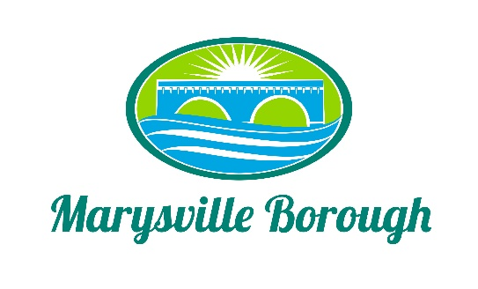

Streets Sewer and Sanitation Meeting Minutes
April 4, 2022
2:15 PM

The Streets, Sewer and Sanitation Committee meeting was called to order at 2:15 PM on Monday, April 4, 2022 at the Marysville Borough Office. Present were Committee Members Lance Barthel, John Edkin and Jackie Zulli, Committee Chair. Also present were Maintenance Workers, Ken Miller and Rob Laman, Sewer Operators Lonnie Sarver and Pete Boele, Borough Engineer, Greg Rogalski and Borough Manager, Zachary Border.

New Business
- Approve Minutes from the Previous Meeting
Lance made a motion and John seconded the motion. During the discussion, John requested that the comments from Lonnie were included in the minutes. After discussion, the motion passed unanimously.
- 216/218 Park Drive
Zach brought up a request to the Committee about the possibility of a mirror so that the owner of 218 would be able to see as she comes out of her driveway. The Committee decided this would not resolve any issues and decided to not move forward with that idea.
- Parking in front of the Memorial Wall (Rich Stees)
Rich was concerned about cars parking in front of the Veteran’s Memorial for an extended period of time. Lance suggested putting up a sign limiting the parking to 15 minutes. The Committee brought up the possibility of making this an ordinance. The Committee decided to wait until the next meeting to make a recommendation to Council.
- 5 Year Paving Plan
Zach wanted to bring up the possibility of creating a 5-Year Plan for paving. The Committee stated that roads were already rated and some were complete already. Greg has a list he will share with Zach and then they can develop a plan based on that document.
Old Business
- Lansvale One-Way Traffic Study Update
Zach updated the Committee stating that PennDOT was still reviewing the study and that we should have more information by next meeting.
- Pump Station 3
At the March meeting, Dave asked if a gravity line could be used instead of a Pump Station. Greg stated that it could work, but it would be very costly due to the depth of the lines in that area.
- Heaters the Sewer Building
There was no new information at this time.

- Skid Loader
The Committee discussed with the Public Works staff what all was wrong with the existing Skid Loader and it’s the condition. The Committee decided to send it to the Finance Committee to try and find the money.

